**Module 2: Linux System**

**Content of course**

* Discuss the three types of permissions used in the Linux Command-Line.
* Describe the three ways of adding text to files.
* Explain the different kinds of help commands used in most Linux distributions.
* Outline the examples of file display commands.

**Command syntax**

Commands options

* Modify the way that a command work.
* Usually consist of a hyphen or dash followed by single letter.
* Some commands accept multiple options which can usually be grouped together after a single hyphen.

Commands arguments

* Most commands are used together with one or more arguments.
* Some commands assume a default argument if none is supllied.
* Arguments are:

1. Optional for some commands
2. Required by others.

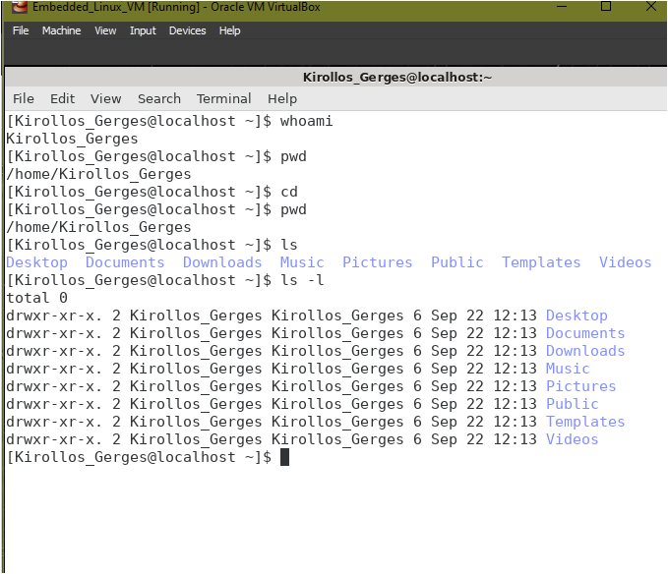

pwd stands for Print Working Directory. It prints the path of the working directory, starting from the root.

pwd is shell built-in command(pwd) or an actual binary(/bin/pwd).

cd stands for "change directory" and is used to navigate the file system on a Linux computer.

When used with a specific directory path as an argument, cd will change the current working directory to that location.

Ls -l option signifies the long list format. This shows a lot more information presented to the user than the standard command.

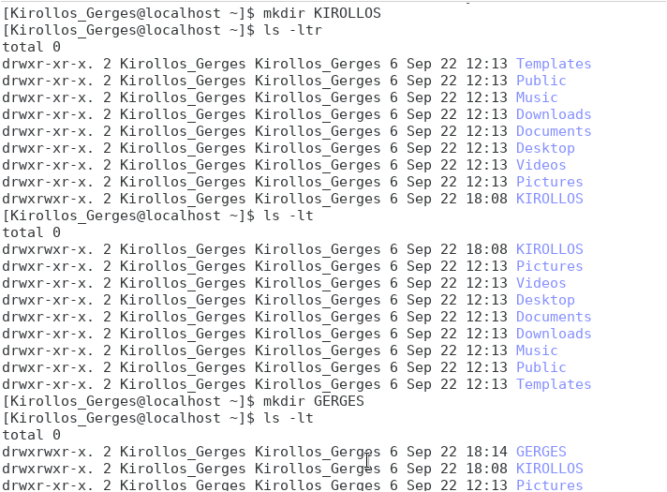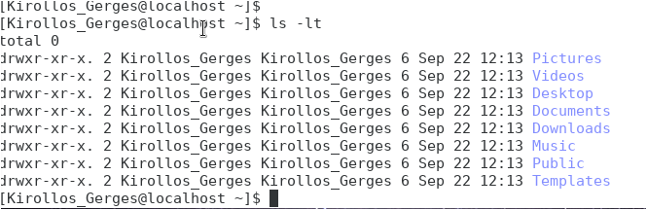Ls –lt :List all document of directory by modification time .

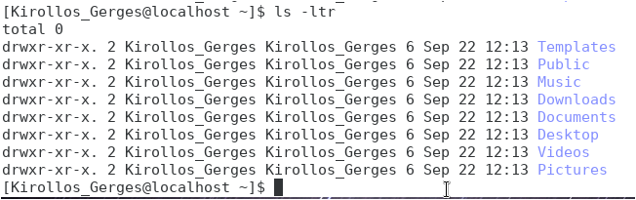Ls –ltr : reverse of ls -lt List all document of directory by modification time .

Mkdir <namespace>: to add new folder on your workspace.

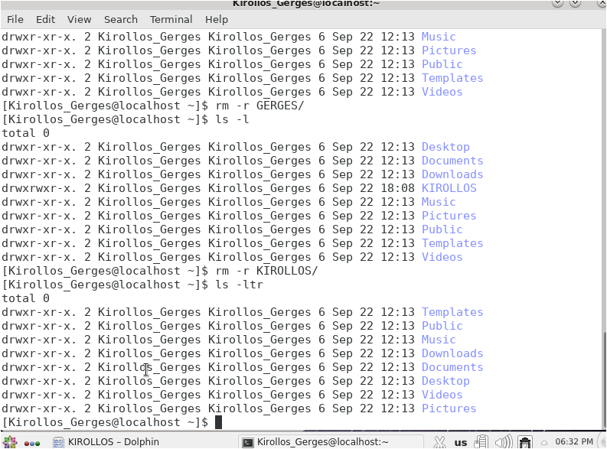rm –r <namespace>/:to remove folder from workspace.

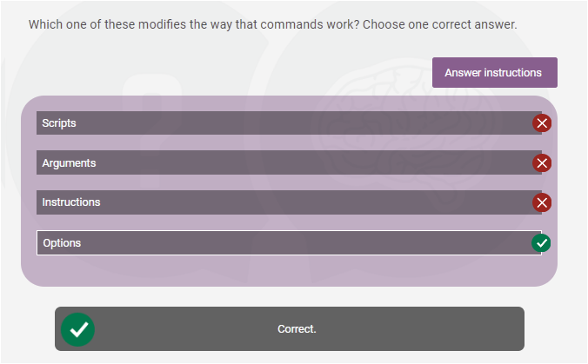



Rm –f <namespace> //force unexciting files to remove.

For more supporting Try rm –help

man ls //manual list .

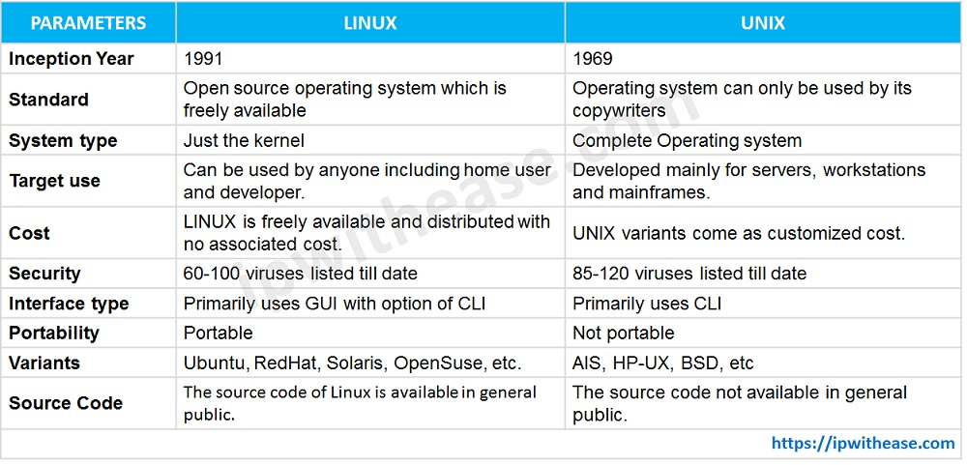**File and Directory Permission “To protect Files”**

The full form of LINUX is Lovable Intellect Not Using XP. Linux was built by and named after Linus Torvalds.

Linux is an open-source operating system for servers, computers, mainframes, mobile systems, and embedded systems.

Requests from device software are handled by Linux and relayed to computer hardware.

What is the full form of UNIX?

The Full Form of UNIX (also referred to as UNICS) is UNiplexed Information Computing System.

A highly popular and multitasking Operating system, launched in 1969, UNIX is powerful.

UNIX is a multi-user system.

Every file and directory in your account can be protected from or made accessible to other users by changing its access permissions.

Every user has responsible for controlling access to their files.

Permissions for a file or directory may be restricted to by types.

r- Read

W- Write

X – Execute (run the program).

Each Permission (rwx) can be controlled at 3 levels:

U – User

g- Group of people for same project,

O- Other, everyone on the system.

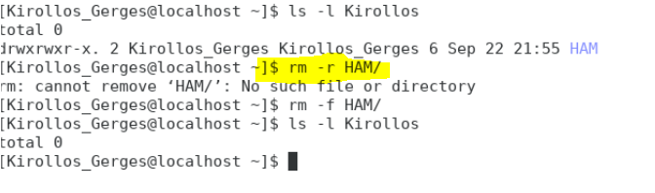

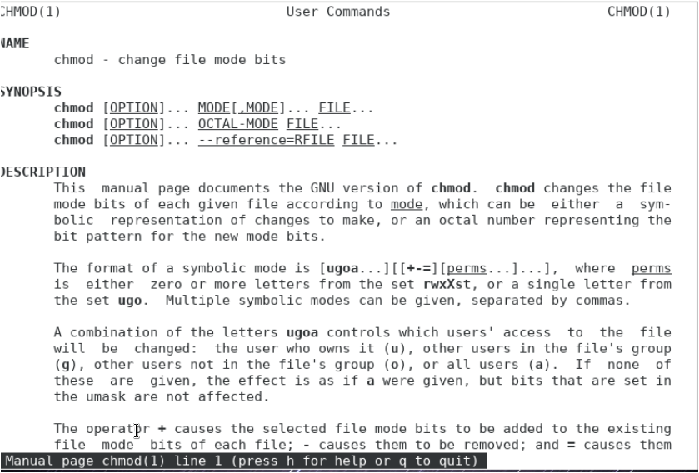Man chmod

Chmod g-w <namespace> //Remove group permission for this work space to write on workspace.

Chmod g-r <namespace> //Remove group permission for this work space to read from workspace

Chmod u-w <namespace> //Remove user permission for this work space to write on workspace.

Chmod u-r <namespace> //Remove user permission for this work space to read from workspace.

rm <name space>

cd <namespace>/

Chmod u+rw <namespace> //Remove user permission for this work space to read or write workspace.

**Permission using Numerical Values**

Assigning numerically

Chmod ugo*r FILE

Chmod 444 FILE

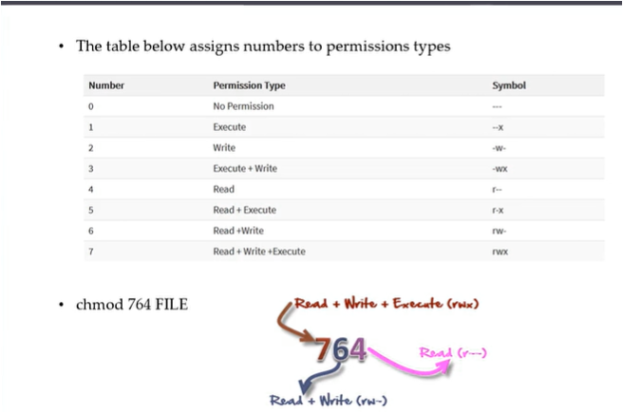

**File ownership commands**

Commands to change file ownership

Chowen changes the ownership of a file.

Chgrp changes the group ownership of a file.

-R: recursive ownership change option(cascade).

Su -:to said that I am the user, to access as a root not a user name.

Chown root FILE: changing the file directory access.

rm FILE_NAME :remove file .

cd /FILENAME: to give accessible for entering this file.

touch FILENAME

Here, the parent option of mkdir helps us to create the parent directory (unless it exists) without any error, while the touch command creates a file. Generally, the touch command doesn't put anything into the file.

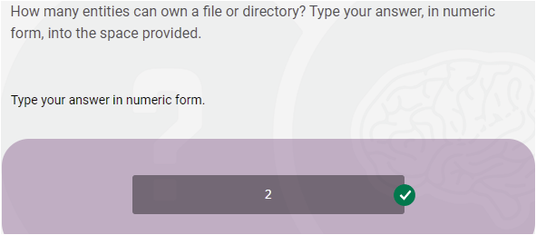

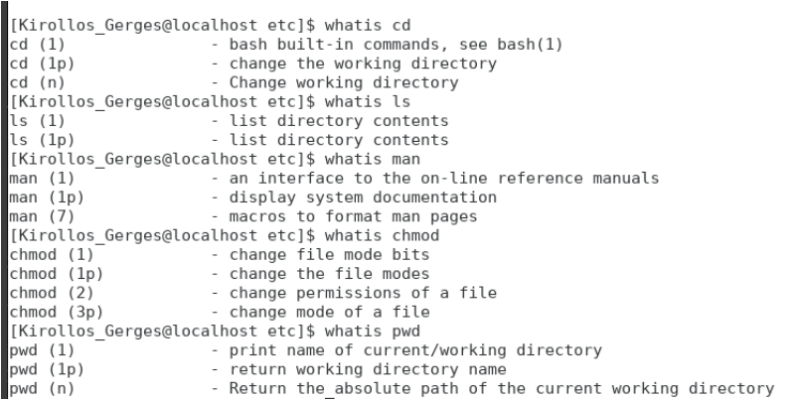**Help Commands**

**3 types**

1. whatis command
2. command –help
3. man command

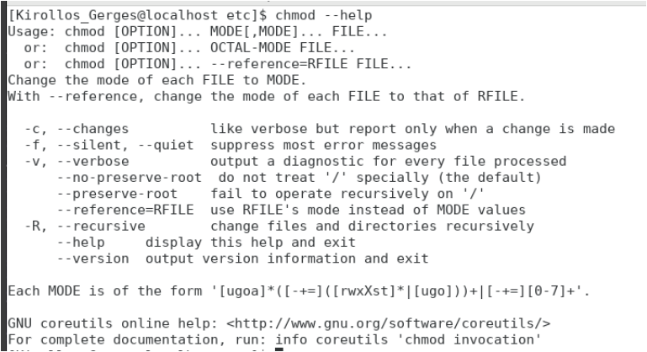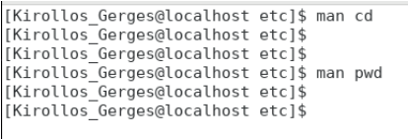

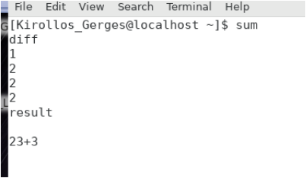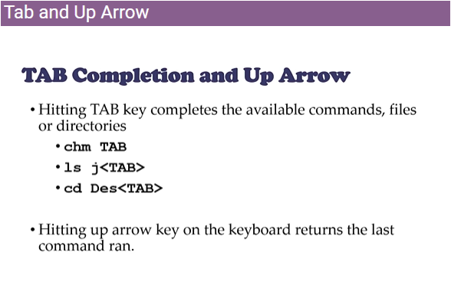**Tab and up Arrow**



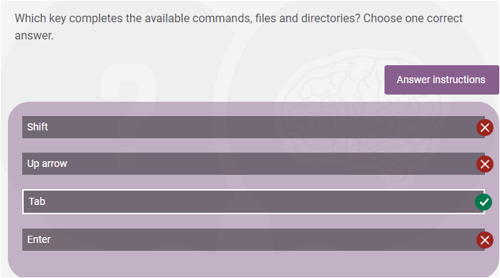

sum command in Linux is used to find checksum and count the blocks in a file.

Basically, this command is used to show the checksum and block count for each specified file. When no file is specified then it will read the standard input. Example: It will ask for the input of the file we want to calculate the checksum.

**Using Pipes**

Used by the shell to connect the output of one command directly to the input of another command.

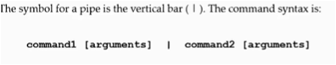

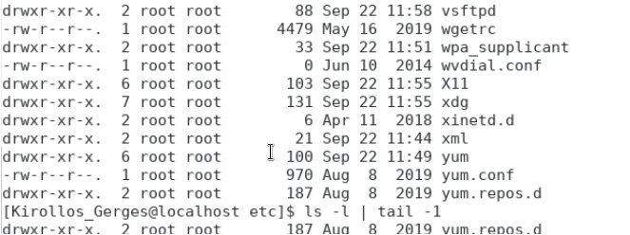

Tail give me the last line or lines.

**Adding text to files [Redirectives]**

3 simple ways:

1. Vi “editor”
2. Redirect command output > or >>.
3. Echo > or >> and cat.

